Solutions

1. 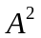 = 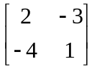= 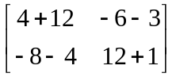=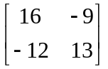

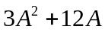 = 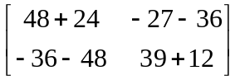= 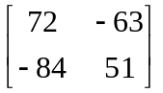
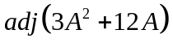 =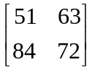
Option (2) , is the correct answer.

2.  